IST 659

Database Implementation Report - Stock Trading System

Table of Contents

Problem Summary 2

Business Rules 2

Entities and Attributes 3

ERD 4

Creation of Tables 5

Insertion of Tables 11

Trigger 20

Major Data Questions 21

login Page 23

Forms 24

Report 29

# Problem Summary

The Stock Trading System is an automated system for trading stocks of publicly traded companies and it has the following data requirements:

A company is uniquely determined by its name, while also having a headquarters address and an established date. Address is a composite attribute, with components street number, apartment number, city, street and zip Code. Some companies have publicly traded common stocks, and are named public companies. Each public company has only one such stock. Each stock has a unique stock code and specified number of shares. Every stock trades on one or more exchanges, but the number of trading exchanges cannot exceed 9. An exchange is uniquely determined by its name. There is a stock symbol associated with a stock, which is used to track trades on an exchange. The same stock may have different symbols on different exchanges. The last trading price and current daily volume for every symbol should be recorded.

Stocks are owned and traded by traders. A trader has a name and a trader id. The trader id uniquely determines the trader. Traders do not trade directly, but via brokers. A broker is uniquely determined by its name and state. Each broker deals with one or more exchanges and pays a fixed yearly fee to every exchange it deals with. The fee could be different for every broker/exchange pair. A trader owns at least one account with at least one broker. She/he may hold more than one account with the same broker and deal with more than one broker. An account is uniquely determined by the broker and account number. A broker may have no accounts. Each account has exactly one owner. Accounts hold securities and cash. Note that a stock bought on one exchange could be sold on another, so it is stocks, not symbols, which are held.

Traders place trading orders via their brokerages. Every transaction contains the following information: number of shares, price, commissions paid by the buyer and the seller to their brokerages and the timestamp. Exchange and transaction number uniquely determine the transaction. Note that an order could be filled by several transactions. The stocks are traded if their orders are fulfilled by some transactions.

# Business Rules

* Each public company has only one such stock, each stock has a unique stock code and specified number of shares.
* Every stock trades on one or more exchanges, but the number of trading exchanges cannot exceed 9.
* A trader owns at least one account with at least one brokerage.
* Each account has exactly one owner.
* The stocks are traded if their orders are fulfilled by some transactions.

# Entities and Attributes

|  |  |
| --- | --- |
| 1. **Account_info** |  |
| 1. account_no | Unique id of each account |
| 1. trader_id | Contains Trader id |
| 1. broker_id | Contains Broker id |
| 1. cash | Contains cash |
| 1. Security | Contains security |
|  |  |
| 1. **Exchange** |  |
| 1. Exchange_id | Unique id of each Exchange |
| 1. Exchange_name | Name of exchange |
|  |  |
| 1. **Company_info** |  |
| 1. Company_id | Unique id of each company |
| 1. Company_name | Name of Company |
| 1. Street_no | Street number of the company |
| 1. City | City in which company resides |
| 1. Zipcode | Zipcode of the company’s location |
| 1. State | State in which company lies |
| 1. Est_date | Date of establishment |
|  |  |
| 1. **Broker_Info** |  |
| 1. Broker_id | Unique id of each broker |
| 1. Broker_name | Name of broker |
| 1. Broker_address | Broker’s address |
| 1. Contact_no | Broker’s contact number |
|  |  |
| 1. **BrokerExchangeDeals** |  |
| 1. ID | Unique id of each deal completed |
| 1. Broker_id | Unique id of each broker |
| 1. Exchange_id | Unique id of each exchange |
| 1. Fees_given | Value of brokerage |
|  |  |
| 1. **Stock_info** |  |
| 1. Stock_id | Unique id of each stock |
| 1. Stock_name | Name of each stock |
| 1. Shares_no | Number of shares |
| 1. S_price | Price of a unit stock |
| 1. Stock_symbol | Tracks trades on an Exchange |
| 1. Company_id | Unique id of each company |
| 1. Trader_exchange_id | Same as exchange_id in |
| 1. Stock_launch_date | Date the stock was launched in the IPO |
|  |  |
| 1. **Trader_details** |  |
| 1. Trader_id | Unique id of each trader |
| 1. Trader_broker_id |  |
| 1. Account_no | Unique id of each account |
|  |  |
| 1. **Transaction_details** |  |
| 1. Order_id | Unique id of each order |
| 1. Stock_id | Unique id of each stock |
| 1. Broker_id | Unique id of each broker |
| 1. Trader_id | Unique id of each trader |
| 1. Exchange_id | Unique id of each exchange |
| 1. No_of_shares | Number of Shares |
| 1. T_Price | Total amount of stocks purchased/sold |
| 1. Brokeragepaidby_seller | Brokerage paid by seller |
| 1. Brokeragepaidby_buyer | Brokerage paid by buyer |

# ERD

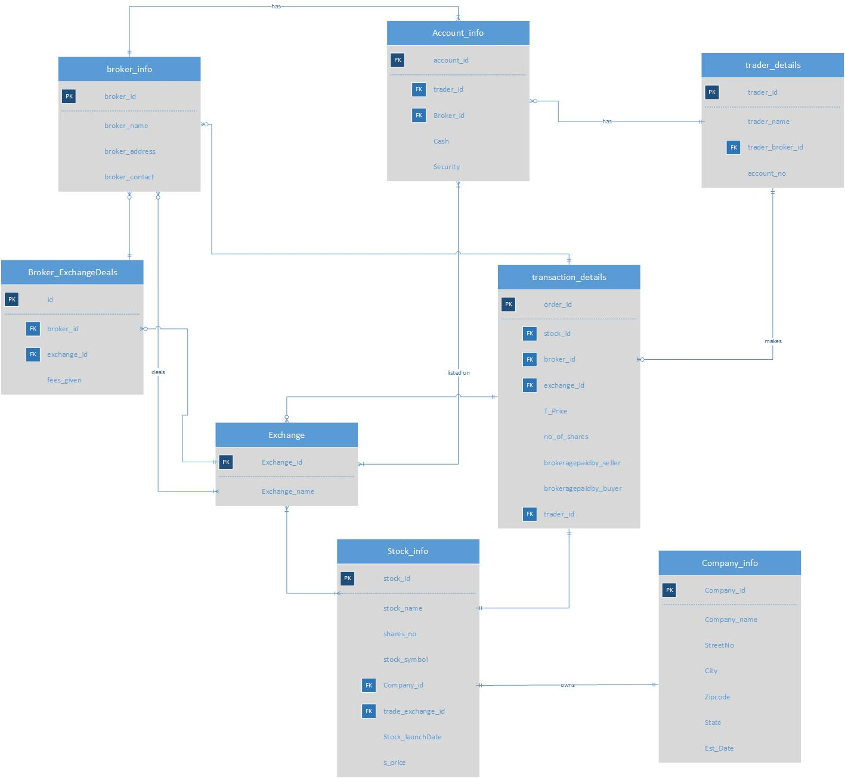

# Creation of Tables

create table company_info

(

company_id char(10) primary key,

company_name VARCHAR(30) NOT NULL,

streetNo VARCHAR(30) NOT NULL,

city VARCHAR (50) NOT NULL,

c_state VARCHAR (50) NOT NULL,

zipcode NUMERIC (10) NOT NULL,

established_date DATETIME NOT NULL

);

create table exchange

(

exchange_id char(10) primary key,

exchange_name varchar(10) NOT NULL

);

CREATE TABLE broker_info(

broker_id char(10) primary key,

broker_fname varchar(30) NOT NULL,

broker_lname varchar(30) NOT NULL,

broker_contact varchar(12) NOT NULL,

broker_streetno numeric(10) NOT NULL,

broker_streetname varchar(50) NOT NULL,

broker_city varchar(30) NOT NULL,

broker_state varchar(30) NOT NULL,

broker_zip numeric(10) NOT NULL

);

CREATE TABLE trader_info(

trader_id char(10) primary key NOT NULL,

trader_fname varchar(30) NOT NULL,

trader_lname varchar(30) NOT NULL,

account_no numeric(9) NOT NULL,

trader_contact varchar(12) NOT NULL,

trader_streetno numeric(10) NOT NULL,

trader_streetname varchar(50) NOT NULL,

trader_city varchar(30) NOT NULL,

trader_state varchar(30) NOT NULL,

trader_zip numeric(10) NOT NULL

);

CREATE TABLE Account_info(

account_id char(10) primary key NOT NULL,

cash numeric(10) NOT NULL,

security numeric(10) NOT NULL,

trader_id char(10) FOREIGN KEY (trader_id) REFERENCES trader_info(trader_id),

broker_id char(10) FOREIGN KEY (broker_id) REFERENCES broker_info(broker_id)

);

CREATE TABLE broker_exchange_deals(

id char(10) primary key,

fees_given char(5),

broker_id char(10) FOREIGN KEY (broker_id) REFERENCES broker_info(broker_id),

exchange_id char(10) FOREIGN KEY (exchange_id) REFERENCES exchange(exchange_id)

);

create table stock_info

(

stock_id char(10) primary key,

stock_name VARCHAR(20) NOT NULL,

shares_no NUMERIC(10) NOT NULL,

stock_symbol varchar(30) NOT NULL,

stock_launchDate DATETIME NOT NULL,

s_price NUMERIC(10) NOT NULL,

company_id char(10) FOREIGN KEY (company_id) REFERENCES company_info(company_id),

trade_exchange_id char(10) FOREIGN KEY (trade_exchange_id) REFERENCES exchange(exchange_id)

);

create table transaction_info

(

order_id char(10) primary key,

T_Price NUMERIC(10) NOT NULL,

No_Of_Shares NUMERIC(10) NOT NULL,

brokeragepaidby_seller NUMERIC(10) NOT NULL,

brokeragepaidby_buyer NUMERIC(10) NOT NULL,

id char(10) FOREIGN KEY (id) REFERENCES broker_exchange_deals(id),

stock_id char(10) FOREIGN KEY (stock_id) REFERENCES Stock_info(stock_id),

broker_id char(10) FOREIGN KEY (broker_id) REFERENCES broker_info(broker_id),

exchange_id char(10) FOREIGN KEY (exchange_id) REFERENCES exchange(exchange_id),

trader_id char(10) FOREIGN KEY (trader_id) REFERENCES trader_info(trader_id)

);

ALTER TABLE transaction_info

ADD account_id char(10) FOREIGN KEY (ACCOUNT_ID) REFERENCES Account_info(account_id);

# Insertion of Tables

insert into company_info values(1, 'Apple', '1', 'Cupertino', 'California', '95014', '1976-04-01');

insert into company_info values(2, 'Google', '1600', 'Menlo Park', 'California', '94043', '1998-09-04');

insert into company_info values(3, 'Amazon', '410', 'Seattle', 'Washington', '98109', '1994-07-05');

insert into broker_info values(1, 'Johnny', 'Walker', '315-555-5555', '45', 'Tiemann Place', 'Manhattan', 'New York', '10027');

insert into broker_info values(2, 'Paul', 'Smith', '315-545-6655', '7906', '5th Avenue', 'Brooklyn', 'New York', '11209');

insert into broker_info values(3, 'Marc', 'New York', '315-343-5566', '4322', 'Queens Street', 'Long Island City', 'New York', '11101');

insert into broker_info values(4, 'John', 'Hopkins', '315-343-7666', '4322', 'Queens Street', 'Long Island City', 'New York', '11101');

insert into  exchange values(1, 'NYSE');

insert into  exchange values(2, 'NASDAQ');

insert into  exchange values(3, 'CSE');

insert into  exchange values(4, 'ASE');

insert into trader_info values(1, 'Yash', 'Pasar', '987651819', '315-450-1430', '212', 'Westcott Street', 'Syracuse', 'New York', '13210');

insert into trader_info values(2, 'Amit', 'Jadhav', '984321819', '315-395-7948', '141', 'Avondale Place', 'Syracuse', 'New York', '13210');

insert into trader_info values(3, 'Devansh', 'Khakkar', '787673219', '315-378-9014', '716', 'South Beech Street', 'Syracuse', 'New York', '13210');

insert into trader_info values(4, 'Manan', 'Dedhia', '654651819', '315-395-7788', '400', 'Westcott Street', 'Syracuse', 'New York', '13210');

insert into account_info values(1, '1800', '1500', '1', '3');

insert into account_info values(2, '2800', '1000', '1', '2');

insert into account_info values(3, '800', '3500', '2', '1');

insert into account_info values(4, '400', '2500', '2', '2');

insert into account_info values(5, '900', '1500', '2', '3');

insert into account_info values(6, '800', '1500', '3', '1');

insert into account_info values(7, '800', '500', '4', '2');

insert into broker_exchange_deals values(1, '0.15', '1', '1');

insert into broker_exchange_deals values(2, '0.25', '1', '2');

insert into broker_exchange_deals values(3, '0.10', '1', '3');

insert into broker_exchange_deals values(4, '0.15', '2', '1');

insert into broker_exchange_deals values(5, '0.25', '2', '2');

insert into broker_exchange_deals values(6, '0.10', '3', '3');

insert into stock_info values(1,'Apple Inc.', '1300', 'AAPL', '1980-12-12', '203.86', '1', '1' );

insert into stock_info values(2,'Apple Inc.', '1300', 'AAPL', '1980-12-12', '203.86', '1', '2' );

insert into stock_info values(3,'Apple Inc.', '1300', 'AAPL', '1980-12-12', '203.86', '1', '3' );

insert into stock_info values(4,'Alphabet Inc.', '1267', 'GOOGL', '1998-09-04', '1241.47', '2', '1' );

insert into stock_info values(5,'Alphabet Inc.', '1267', 'GOOGL', '1998-09-04', '1241.47', '2', '2' );

insert into stock_info values(6,'Alphabet Inc.', '1267', 'GOOGL', '1998-09-04', '1241.47', '2', '3' );

insert into stock_info values(7,'Amazon.com Inc.', '900', 'AMZN', '1997-11-11', '1861.69', '3', '1' );

insert into stock_info values(8,'Amazon.com Inc.', '900', 'AMZN', '1997-11-11', '1861.69', '3', '2' );

insert into stock_info values(9,'Amazon.com Inc.', '900', 'AMZN', '1997-11-11', '1861.69', '3', '3' );

insert into stock_info values(10,'Amazon.com Inc.', '900', 'AMZN', '1997-11-11', '1861.69', '3', '4' );

insert into transaction_info values(1,20400,100,12,30,1,1,1,1,1,1 );

insert into transaction_info values(2,10200,50,6,15,2,2,2,2,2,4 );

insert into transaction_info values(3,16728,82,42,30,1,3,2,1,3,6 );

insert into transaction_info values(4,16728,82,42,30,1,3,2,1,3,6 );

insert into transaction_info values(5,11120,55,42,30,1,3,2,1,3,6 );

insert into transaction_info values(17,1320,5,42,30,1,3,2,1,3,6 );

SELECT * FROM company_info;

SELECT * FROM broker_info;

SELECT * FROM exchange;

SELECT * FROM trader_info;

SELECT * FROM account_info;

SELECT * FROM broker_exchange_deals;

SELECT * FROM stock_info;

SELECT * FROM transaction_info;

# Trigger

drop trigger S_Quantity

create trigger S_Quantity

ON transaction_info

AFTER INSERT

AS

DECLARE @No_Of_Shares AS INT

DECLARE @T_Price AS INT

SET @No_Of_Shares = (SELECT TOP 1 inserted.No_Of_Shares FROM inserted)

SET @T_Price = (SELECT TOP 1 inserted.T_Price FROM inserted)

IF @No_Of_Shares<50

BEGIN

 RAISERROR  ('Number of shares should be greater than or equal to 50',15,1);

  ROLLBACK

END

if @T_Price < 10000

BEGIN

 RAISERROR  ('Total transaction value has to be greater than or equal to 10000',15,1);

  ROLLBACK

# Major Data Questions

/* 1. For each public company list the number of exchanges which its stock trades on */

select s.stock_name, count(s.trade_exchange_id) as No_of_exchanges

from stock_info s

group by s.stock_name

ORDER BY No_of_exchanges;

/* 2. List all Exchanges who have stock from the public company established before “Jan01,1982” */

select e.exchange_name

from exchange e

inner join stock_info s on s.trade_exchange_id = e.exchange_id

inner join company_info c on c.company_id = s.company_id

where c.established_date < '1982-01-01';

/* 3. Find each Trader who has exactly one account */

select a.trader_id

from account_info a

group by a.trader_id

having count(a.account_id) = 1;

/* 4. Find all Brokerages who do not have any accounts */

select b.broker_fname,b.broker_lname, b.broker_id

from broker_info b

left join account_info as a

on b.broker_id = a.broker_id

where b.broker_id

not in (select distinct(broker_id) from account_info);

/* 5. List all stocks belonging to each Exchange */

Select stock_name, exchange_name

from stock_info as s

join exchange as e on s.trade_exchange_id = e.exchange_id

order by s.stock_name

# login Page

1. Admin Login

1. Trader Login

1. Interface once logged in

# Forms

1. Broker Form

1. Company Form

1. Stock Form

1. Trader

1. Purchases

# Report

1. Admin Report

1. Individual Trader Report

